Schematic Review

Schematic Date: 2/20/2019 2:57PM

ADD COVER SHEET:

- ADD: Summary schematic block diagram of how things fit together

- ADD: Summary of connectors and purpose

- ADD: Summary of LED's and purpose

- MOD: Document Rev = 1.0

- please modify this number any time the schematic changes

Q: Is there any need for the 2.8V power? Or can we limit the board to 5V, 3.3V, and 1.8V?

VDD_IO = 1.8V

J1

- ADD: label "to 1500-OEM J4" below part

- MOV: "J1" above part for easy identification

- ADD: 0Ohm resistor between Pin 44 and Ground

- matches original design

- ADD: P13 "GPIO174" goes to U1P17 (Reset)

- GPIO174 is VIOSEL level

- 1500-OEM will actively cycle the RESET line

- ADD: P19 "GPIO178" U1P22 (Standby)

- GPIO178 is 3.3 level (not VIOSEL)

- ADD: P14 "GPIO173" goes to U1P26 (FLASH) with 0Ohm Resistor (DNP)

- ADD: P40 "GPIO172" goes to U1P27 (TRIGGER) with 0Ohm Resistor (DNP)

J2

- DEL: J2P4 and J2P5 to UART_RX_CAM and UART_TX_CAM.

- We'll use RXC & TXC (SightLine /dev/ttyO1) to communicate MAVLINK to Pixhawk

- ADD: since J1P46 (VIOSEL) == VDD_IO == 1.8V, pins 2&3 and 4&5 will need to be shifted from 3.3V to 1.8V

- use TXB0104YZTR or similar

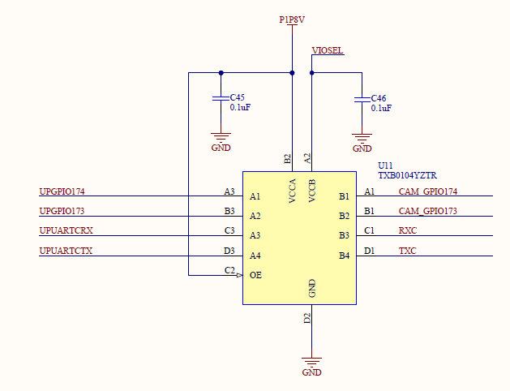

J3 - "AUX SERIAL PORT"

- MOD: P3 to J1P1 (UART_RX_CAM = /dev/ttyO2)

- MOD: P2 to J1P2 (UART_TX_CAM = /dev/ttyO2)

J4 = OK

J5 = OK

J6

- MOD: change text to "AUX POWER INPUT"

- we don't want any to use this as an output as it may exceed current limit of Pixhawk

U1

- List the I2C address for the chip (0x?? or binary)

TODO:

J1P21 EXT_SYNC to AR0134?

J1P43 to MCX for analog video input?

ADD: Test points

- GROUND clip to make probing board easier.

- PIXCLK

- LINE_VALID

- FRAME_VALID